Query all attributes of every Japanese city in the CITY table. The COUNTRYCODE for Japan is JPN.

Input Format

The CITY table is described as follows:

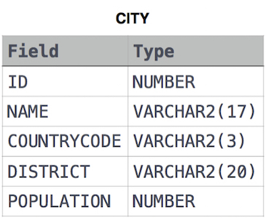

Solution:

SELECT \*

FROM CITY

WHERE COUNTRYCODE LIKE 'JPN';